

East West University

Project Report

**Computer Networks**

**Course Code:** CSE 405

**Sec:** 02

**Prepared for**

# Dr. Anisur Rahman

# Associate Professor

# Department of Computer Science and Engineering,

# East West University

**Prepared By**

Name: Angon Bhadra Antu

Id: 2020-1-60-163

Date of Submission: 22.05.23

# Introduction:

**Background:**

University of Scholars, is an enterprise like East West University, owns many computers, with a complex network infrastructure. Apart from wired internet access to all the classrooms, labs, employee PCs, library and other administrative and academic wings, the university also provides wireless internet access for every campus. On top of that the university runs a complex networked systems to support several of its business process like admissions, advising, results, eTender, library management, accounts and so on.

**Statements & Features:**

Computer Networks consists of multiple computer systems and other computing hardware devices that are interconnected to share information. In order to facilitate the connections, routers, switches, and hubs are often employed.

In this particular project, I have implemented a comprehensive network for University of Scholars, an enterprise like East West University. The network comprises seven routers, each representing a different campus. Additionally, I have included 2960 switches to connect the computers, and for wireless connectivity, I have chosen the WRT300N router. To manage all IP address allocation, Single DHCP server is connected to switch under Campus 1 to configure all the class A,B,C Ip assignment for the PC’s. Also it is equipped with a DNS server and a WEB server. I’ve configured the DNS server with the university's URL, "http://www.scholars.edu.bd." enabling users to browse the university's website.

# Tools & Components Used:

* Cisco Packet Tracer
* DHCP Server
* DNS Server
* WEB Server
* Generic End Devices (for pc)
* Routers (PT Router)
* WRT300N (Wireless device)
* Switch (2960)
* Laptop
* Wireless Smartphone
* Wireless End Device
* Connectors (Serial DCE with clock, Copper Straight Through )

# Complete Network Workspace:

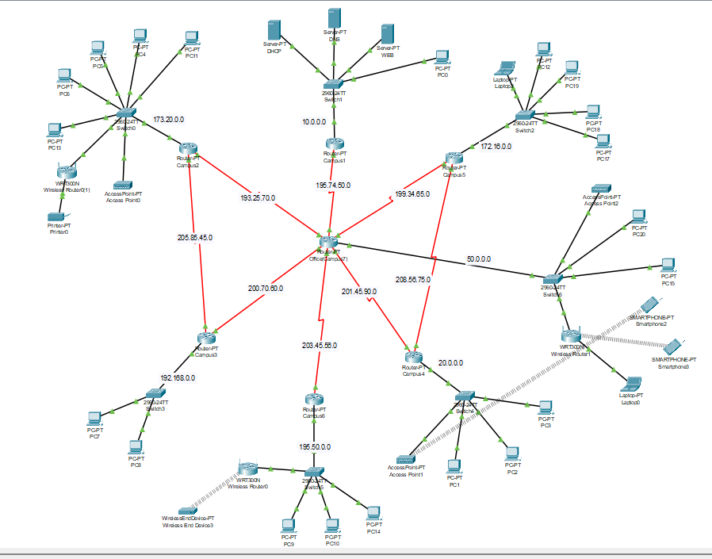

Campus Router Interfaces & Diagram:

I’ve used IP classes A, B and C for the whole network.

**Router 1:**

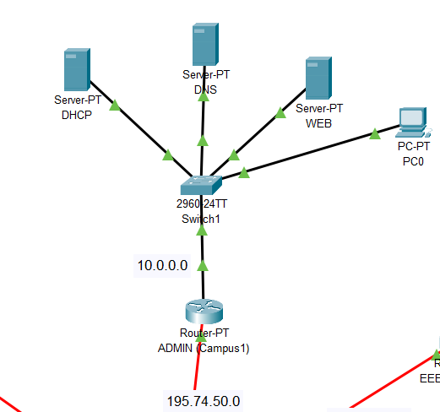

Router-I is named as (ADMIN)Campus-l. It consists ServerRoom and monitoring Pc basically.

For campus-I, I have taken the IP from the A-Class. The network IP for Campus-I is 10.0.0.0

Router 2:

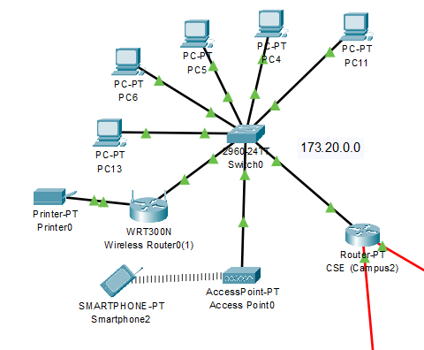

Router-2 is named as (CSE)Campus-2. It consists multiple Pcs, printer and wireless router for wireless connection. For campus-2, I have taken the IP from the B-Class. The network IP for Campus-2 is 173.20.0.0

Router 3:

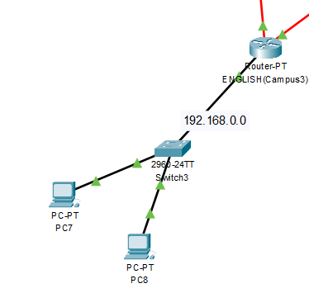

Router-3 is named as (ENGLISH)Campus-3. It consists OF two Pc basically connected with a switch

For campus-3, I have taken the IP from the C-Class. The network IP for Campus-I is 192.168.0.0

Router 4:

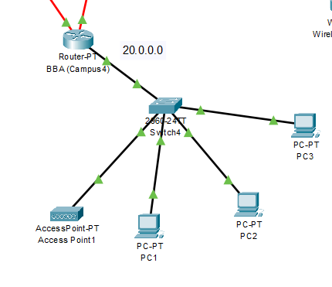

Router-4 is named as (BBA)Campus-4. It consists of multiple Pc’s and access point.

For campus-4, I have taken the IP from the A-Class. The network IP for Campus-I is 20.0.0.0

Router 5:

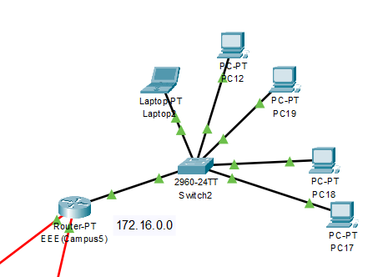

Router-5 is named as (EEE)Campus-5 where there are multiple PC and laptop connected for lab or other operations.

For campus-5, I have taken the IP from the B-Class. The network IP for Campus-I is 172.16.0.0

Router 6:

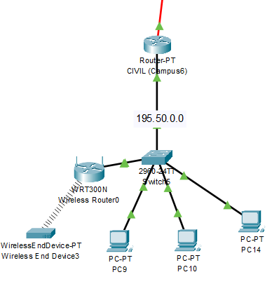

Router-5 is named as (CIVIL)Campus-5 where there are multiple PC Wireless end device and wireless router are connected for wireless and wired connection as well.

For campus-6, I have taken the IP from the C-Class. The network IP for Campus-I is 195.50.0.0

Router 7:

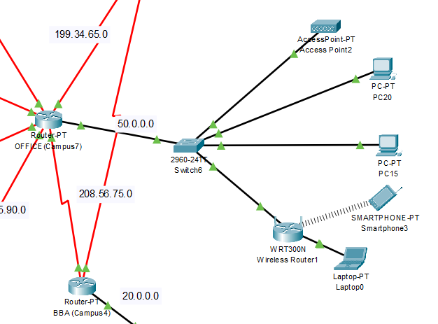

Router-7 is named as (OFFICE)Campus-7 where there are multiple PC, wireless router and wireless devices -laptop, smartphone are connected.

For campus-7, I have taken the IP from the A-Class. The network IP for Campus-I is 50.0.0.0

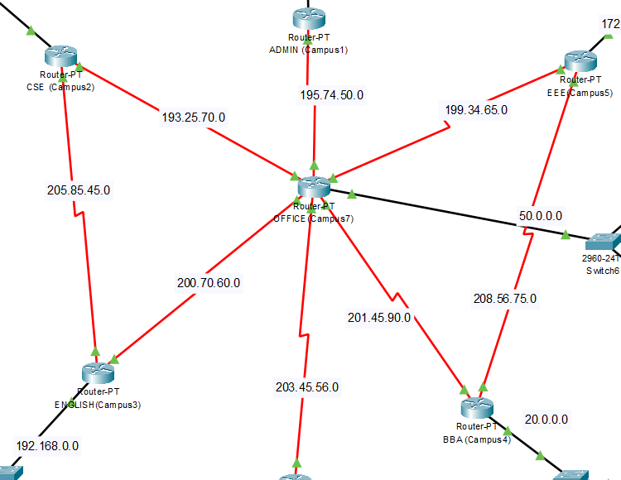

Router Configuration & OSPF routing Table:

**Campus 1**

interface fa0/0

ip address 10.0.0.254 255.0.0.0

no shut

do wr

exit

interface se2/0

ip address 195.74.50.1 255.255.255.0

no shut

do wr

exit

router ospf 1

network 10.0.0.0 0.255.255.255 area 1

network 195.74.50.0 0.0.0.255 area 1

exit

**Campus 2**

interface fa0/0

ip address 173.20.0.254 255.255.0.0

no shut

do wr

exit

interface se2/0

ip address 193.25.70.1 255.255.255.0

no shut

do wr

exit

interface se7/0

ip address 205.85.45.1 255.255.255.0

clock rate 64000

no shut

do wr

exit

router ospf 2

network 173.20.0.0 0.0.255.255 area 1

network 193.25.70.0 0.0.0.255 area 1

network 205.85.45.0 0.0.0.255 area 1

exit

**Campus 3**

interface fa0/0

ip address 192.168.0.254 255.255.255.0

no shut

do wr

exit

interface se2/0

ip address 205.85.45.2 255.255.255.0

no shut

do wr

exit

interface se6/0

ip address 200.70.60.1 255.255.255.0

no shut

do wr

exit

router ospf 3

network 192.168.0.0 0.0.0.255 area 1

network 205.85.45.0 0.0.0.255 area 1

network 200.70.60.0 0.0.0.255 area 1

exit

**Campus 4**

interface fa0/0

ip address 20.0.0.254 255.0.0.0

no shut

do wr

exit

interface se2/0

ip address 201.45.90.1 255.255.255.0

no shut

do wr

exit

interface se3/0

ip address 208.56.75.1 255.255.255.0

no shut

do wr

exit

router ospf 4

network 20.0.0.0 0.255.255.255 area 1

network 201.45.90.0 0.0.0.255 area 1

network 208.56.75.0 0.0.0.255 area 1

exit

**Campus 5**

interface fa0/0

ip address 172.16.0.254 255.255.0.0

no shut

do wr

exit

interface se2/0

ip address 199.34.65.1 255.255.255.0

no shut

do wr

exit

interface se3/0

ip address 208.56.75.2 255.255.255.0

clock rate 64000

no shut

do wr

exit

router ospf 5

network 172.16.0.0 0.0.255.255 area 1

network 199.34.65.0 0.0.0.255 area 1

network 208.56.75.0 0.0.0.255 area 1

exit

**Campus 6**

interface fa0/0

ip address 195.50.0.254 255.255.255.0

no shut

do wr

exit

interface se2/0

ip address 203.45.56.1 255.255.255.0

no shut

do wr

exit

router ospf 6

network 195.50.0.0 0.0.0.255 area 1

network 203.45.56.0 0.0.0.255 area 1

exit

**Campus 7**

interface fa0/0

ip address 50.0.0.254 255.0.0.0

no shut

do wr

exit

interface se2/0

ip address 199.34.65.2 255.255.255.0

clock rate 64000

no shut

do wr

exit

interface se3/0

ip address 195.74.50.2 255.255.255.0

clock rate 64000

no shut

do wr

exit

interface se6/0

ip address 193.25.70.2 255.255.255.0

clock rate 64000

no shut

do wr

exit

interface se7/0

ip address 200.70.60.2 255.255.255.0

clock rate 64000

no shut

do wr

exit

interface se8/0

ip address 201.45.90.2 255.255.255.0

clock rate 64000

no shut

do wr

exit

interface se9/0

ip address 203.45.56.2 255.255.255.0

clock rate 64000

no shut

do wr

exit

router ospf 7

network 50.0.0.0 0.255.255.255 area 1

network 199.34.65.0 0.255.255.255 area 1

network 195.74.50.0 0.255.255.255 area 1

network 193.25.70.0 0.255.255.255 area 1

network 200.70.60.0 0.255.255.255 area 1

network 201.45.90.0 0.255.255.255 area 1

network 203.45.56.0 0.255.255.255 area 1

exit

**Assigning Ip helper**

For each campus connected to fa0/0 interface ip helper is assigned to get IP from DHCP server

en

config

interface fa0/0

ip helper-address 10.0.0.15

exit

Servers Setup:

DHCP:

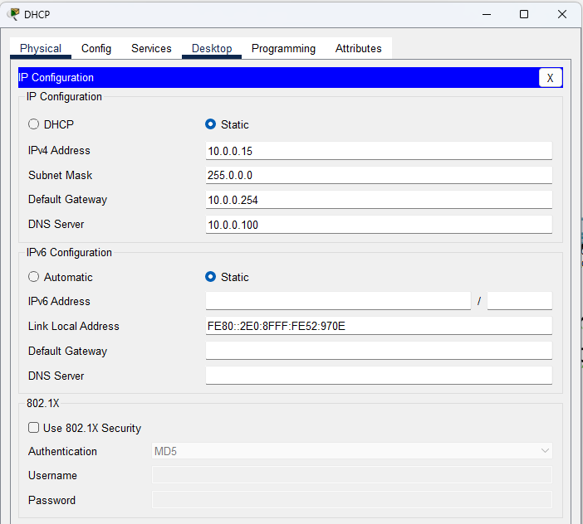

Figure: DHCP Server IP Config

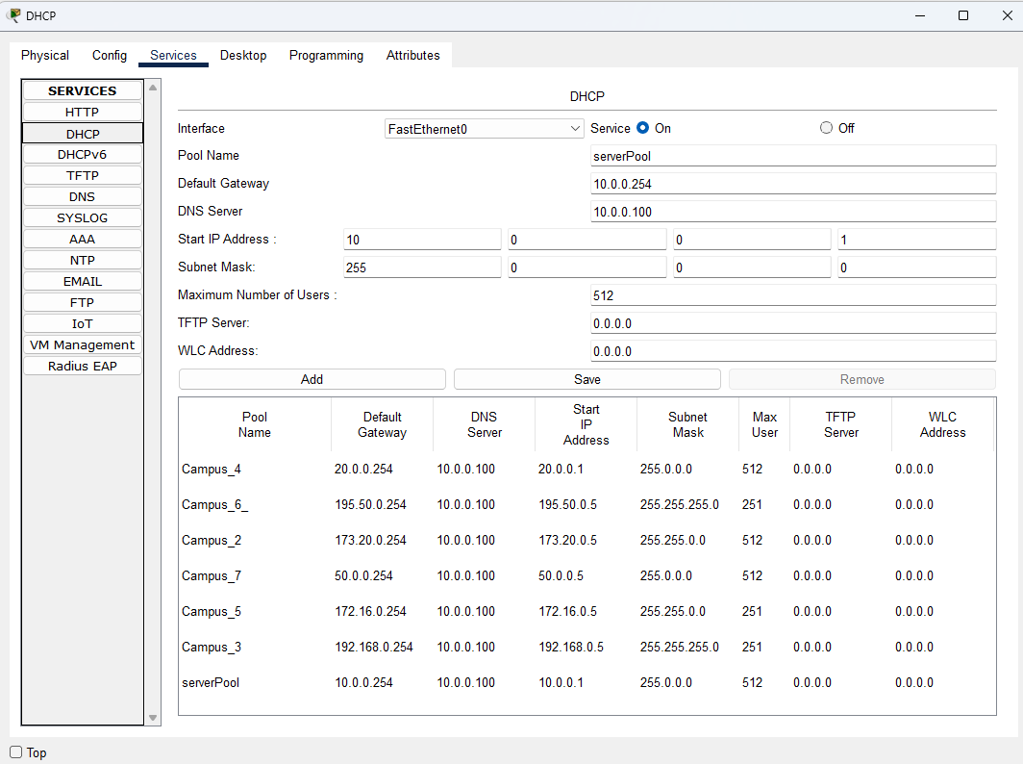

Figure: Server Pool for All Different IP Config

DNS:

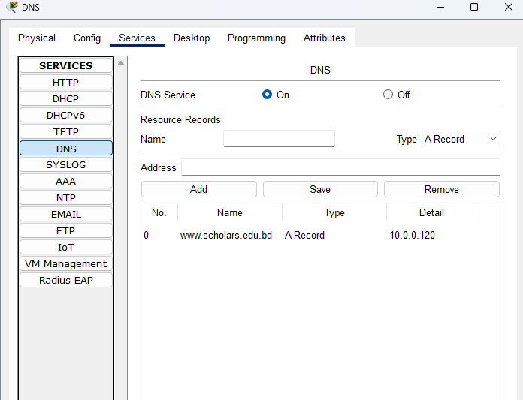

Figure: DNS Server Record Config

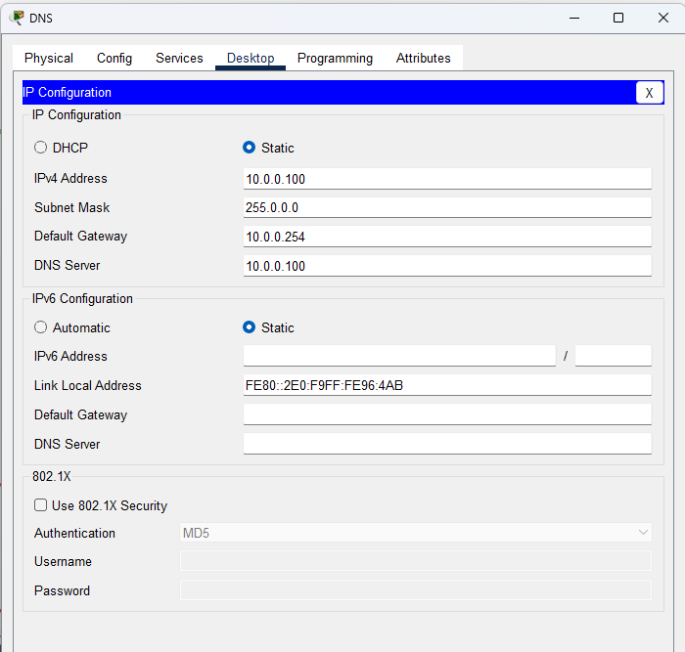

Figure: DNS Server IP Config

WEB:

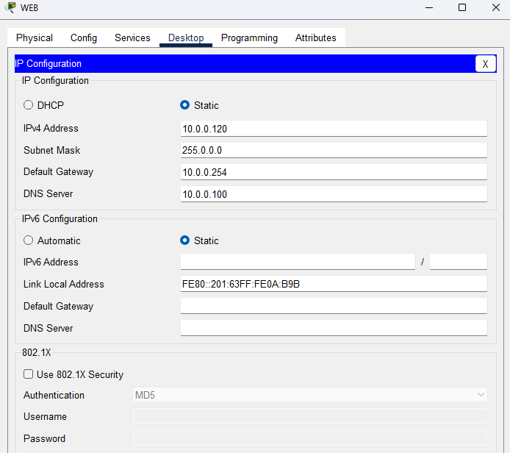

Figure: WEB Server Record Config

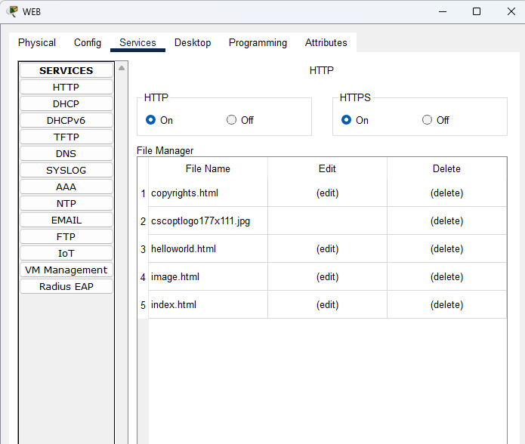

Figure: WEB Server On Status

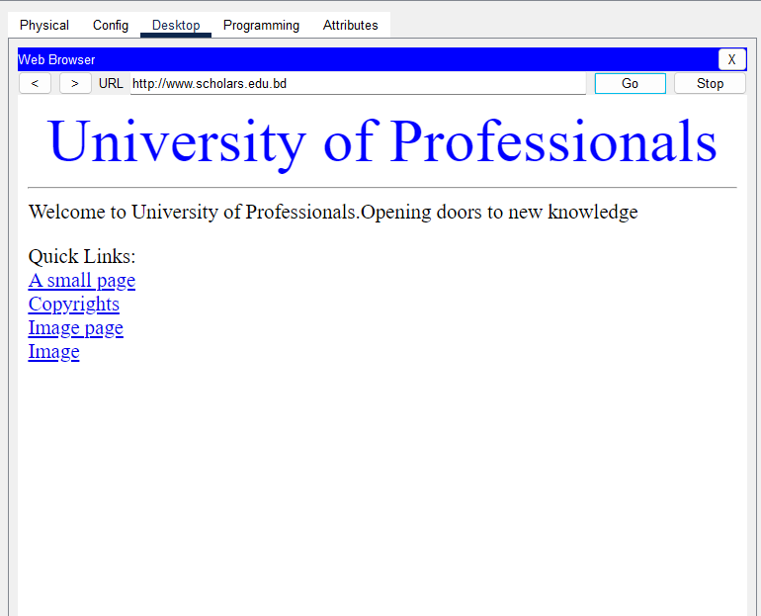

Figure: WEB Page Accessing with URL instead of IP Address

I create A webpage of Scholars University accessible form any pc or any network in this university. Web address : www.scholars.edu.bd Ip against web address :10.0.0,100 by using DNS server.

# PC Configuration:

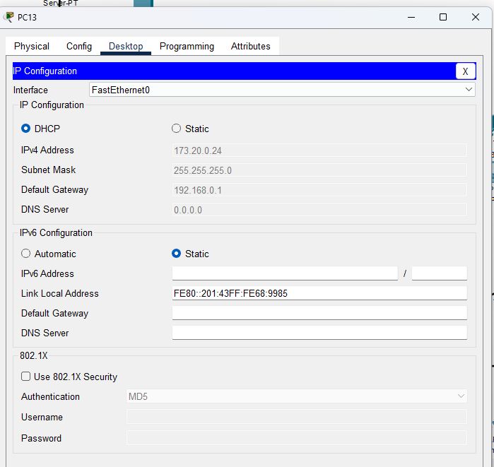

Figure: DHCP IP Assignment for PC

# PDU:

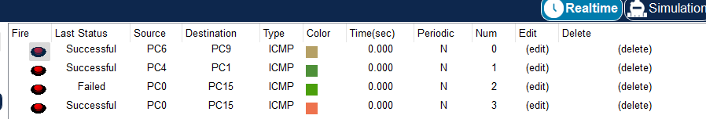

Figure: Successful Packet Tranmission between PC’s

Limitation:

In this project, I haven’t incorporated subnets which could give some extra network facility in that network. I configured the whole network in such a way that IP for the hosts of different campuses will be automatically assigned by a single DHCP server. By following this process, this University of Professionals network can operate their task properly. Also, increased number of ports and host will help to remain the network more scalable

# Conclusion:

In my project, I learned about building a project using CISCO Packet Tracer. Despite some difficulties encountered while setting up the network,I have tried to build a complex network where there are most kind of possible devices are incorporated. I use single DHCP server for all class networks. I use the class A,B,C Ip address in this project. The web server generates the web page reflecting the university’s profile. Overall, with the knowledge gained & experience earned doing the project will be beneficial in future projects.